**A PROJECT PROPOSAL**

**ON**

**“Crop Recommendation System”**

|  |  |
| --- | --- |
| ***Submitted by:***  **Md. Azizur Rahman 20211103014**  **Md. Azmol Hasan Ratul 20211103023**  **Feroz Ahmed 20211103026**  **Nasim Reza 20211103030** | ***Submitted to,***  **Shraboni Afroz**  **Designation: Lecturer**  **Department of Computer Science & Engineering**  **Bangladesh University of Business**  **And Technology (BUBT)** |

***In partial fulfillment of the requirements for the degree of***

**BACHELOR OF SCIENCE**

**IN**

**COMPUTER SCIENCE AND ENGINEERING**



**DEPARTMENT OF COMPUTER SCIENCE AND ENGINEERING BANGLADESH UNIVERSITY OF BUSINESS AND TECHNOLOGY (BUBT) DHAKA**-**1216**

**1. Executive Summary**

We propose the development of a Crop Recommendation System (CRS) that leverages data analytics, machine learning, and agricultural expertise to provide farmers with personalized crop recommendations. This system aims to optimize crop selection, improve yield, and enhance sustainable farming practices.

1. **Project Objective**

Primary objectives of the Crop Recommendation System are:

* To assist farmers in making informed decisions about crop selection based on factors such as soil type, climate, historical data, and market demand.
* To increase agricultural productivity and profitability by optimizing crop choices and resource allocation.
* To promote sustainable farming practices by recommending crops that are suitable for a given region and season, reducing resource wastage and environmental impact.
* To provide an easy-to-use and accessible platform for farmers to access crop recommendations and related agricultural information.

1. **Project Scope**

* Data Collection: Gathering data on soil quality, weather conditions, historical crop yields, and market demand for various crops.
* Data Analysis: Employing data analytics and machine learning techniques to process and analyze the collected data.
* Recommendation Engine: Developing an intelligent recommendation engine that generates crop recommendations based on the analyzed data.
* User Interface: Creating a user-friendly web or mobile application for farmers to access crop recommendations and additional agricultural information.
* Testing and Validation: Conducting rigorous testing and validation to ensure the accuracy and effectiveness of the recommendation system.
* Training and Support: Providing training and ongoing support for farmers to effectively use the system.

1. **Methodology**

* Data Collection: Collaborate with local agricultural agencies and research institutions to gather relevant data on soil, climate, and historical crop performance.
* Data Analysis: Employ data preprocessing, feature engineering, and machine learning algorithms to analyze the collected data.
* Recommendation Engine: Develop a recommendation engine that considers various factors, including soil type, weather conditions, and market demand, to generate crop recommendations.
* User Interface: Design an intuitive and user-friendly interface for farmers to access recommendations and input their farm-specific data.
* Testing and Validation: Perform rigorous testing and validation through real-world trials and comparisons with existing methods.
* Deployment: Deploy the CRS as a web or mobile application, accessible to farmers and agricultural experts.

1. **Expected Outcomes**

The expected outcomes of the Crop Recommendation System project include:

* Improved crop yields and profitability for farmers.
* Enhanced sustainability through optimized resource allocation.
* Accessible and user-friendly technology for farmers.
* Reduction in agricultural resource wastage.
* Data-driven insights for agricultural research and planning.

1. **Overall System Architecture**

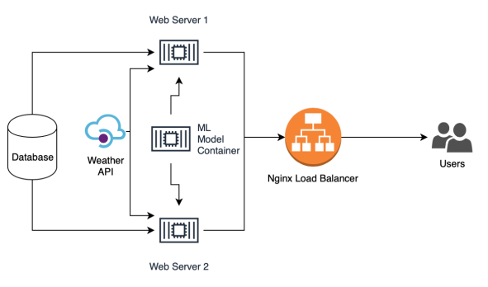

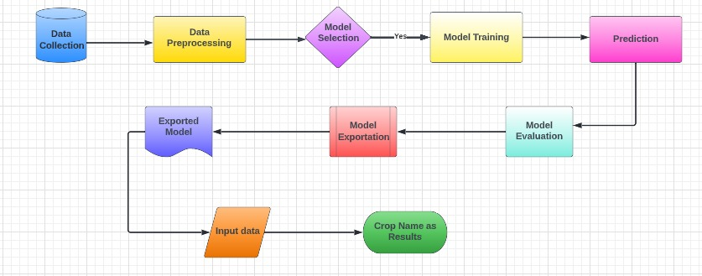

1. **Conclusion**

The Crop Recommendation System project aims to revolutionize agriculture by providing farmers with data-driven recommendations for crop selection. By optimizing crop choices and resource allocation, this system will improve agricultural productivity, profitability, and sustainability. We seek support and funding to bring this project to fruition and empower farmers with technology-driven solutions.